# Functional Decomposition

Functional decomposition was performed to break down the complex system into smaller, more manageable subfunctions. This was done to clarify the overall objective and requirements of the product by isolating individual parts and analyzing their interactions. To enhance understanding of the system, a visual model was produced in the form of a hierarchal display and a cross-reference table was generated.

**Data Generation**

Multiple sources were used to generate the data necessary to complete functional decomposition, the main one being the project sponsors. Throughout a series of meetings and emails with Rockwell Automation, customer needs were communicated, which the design team interpreted into engineering needs. These needs directed the functional decomposition, alongside analysis on the current state of the product. To obtain a better understanding of how the product is currently operating, the previous design team who worked on the project was contacted. The catalog of information obtained shaped the system and allowed it to be broken down into functions and subfunctions.

**Graphic Introduction**

A hierarchal flowchart, shown in Figure 1, was generated based on the selected functions and subfunctions. This was done to visualize the relationships between the functions and subfunctions. The system is labeled at the top, with the main functions connected beneath it. These main functions branch further down into more detailed subfunctions. With the system being an automated manufacturing device for STEM engagement, four main functions were derived: *Manufacture*, *Educate*, *Control*, and *Support*. These were further simplified into subfunctions, as displayed in Figure 1.

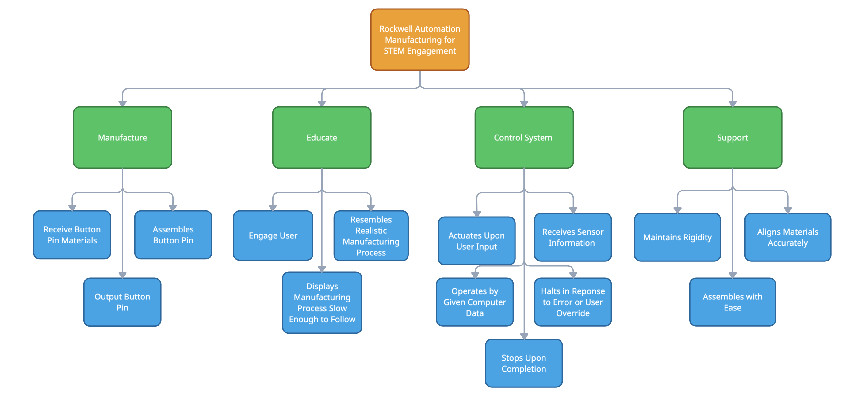

Figure 1. Functional Decomposition Hierarchy Chart

Table 2 shows the produced cross reference table from the identified functions and subfunctions. The four main functions are displayed in row 1, and the subfunctions are listed in column 1. An “X” is placed in the corresponding column if the subfunction relates to the main function. This provides a visual representation of the influence the functions have on each other.

Table 2. Function Cross Reference Table

|  |  |  |  |  |
| --- | --- | --- | --- | --- |
|  | Manufacture | Educate | Control | Support |
| Receive button pin materials | X |  |  |  |
| Assembles button pin | X |  |  |  |
| Output button pin | X |  |  |  |
| Engage user |  | X |  |  |
| Displays manufacturing process slow enough to follow | X | X |  |  |
| Resembles realistic manufacturing process | X | X |  |  |
| Actuates upon user input | X | X | X |  |
| Receives sensor information |  |  | X |  |
| Operates by given computer data | X |  | X |  |
| Halts in response to error or user override |  | X | X |  |
| Stops upon completion | X | X | X |  |
| Maintains rigidity |  |  |  | X |
| Aligns materials accurately |  |  | X | X |
| Assembles with ease |  |  |  | X |

The primary purpose of the product is to educate K-12 students on an automated manufacturing process. The main functions were identified with this in mind, as well as a focus on improving the current state of the product. Rockwell emphasized the importance of fail-safe measures in the product, and the design team identified potential safety issues to properly generate the functional decomposition. One of the largest safety issues was noted as the *Support*, making it one of the main functions. The four main functions work together to achieve the customer needs in the final system. The *Educate* function is achieved through viewing the manufacturing process, which is automated but includes *Control* measures for the user to operate in case of failure. The product is intended to be assembled, disassembled, and transported with ease. The above functions and subfunctions ensure a safe, successful project based on the interpreted customer needs.

**Connection to Systems**

The main objectives of the project are to reduce errors and industrialize the results of the previous design team. This includes an increase in reliability and reduction of user interaction. If priority is placed on the *Manufacture* function, the product may lack in the objective of reducing errors. As the product exists with a current design that emphasizes manufacturing, priority will be placed on *Control* instead. This will allow the process to be as safe and reliable as possible, with a reduction in user errors. The project objectives will be met, as the focus is on improvement of the current system and not design of a new system.

**Smart Integration**

Many of the functions and subfunctions generated will influence each other to varying degrees. Three of the major functions, *Manufacture*, *Educate*, and *Control*, highly interact with each other. As the product operates, it manufactures a button pin. As the given subfunctions are met, the user will follow the process with ease and gain exposure to a realistic manufacturing environment. The *Manufacture* and *Control* subfunctions work together to *Educate* the audience. The *Support* function influences the *Manufacture* function, as the product must maintain stability to successfully complete the manufacturing process.

**Actions and Outcomes**

To satisfy all customer needs, the device must *Educate* the audience by showing them the manufacturing process and ensuring they are fully engaged during the presentation. It should *Manufacture* an object by taking in button pin materials, manipulating them, and outputting a fully functioning button pin. This process needs to *Control* the system by using a fully automated control system that starts, stops, pauses, and fault resets as needed. It will rely on sensors to gather data, analyze it, and send instructions to output devices to manipulate the button pin materials. Before outputting the button pin, the device should inspect its quality and discard any that do not meet standards. Throughout these operations, the structure must S*upport* all its components, reinforcing and ensuring stability whether stationary or while being moved.

**Function Resolution**

The product must manufacture a button pin for STEM engagement in K-12 schools. There are many functions and subfunctions that contribute to the success of the project; however, the smallest is actuating upon user input. The simple press of a button is a brief, but vital step as it initiates the entire manufacturing and education process.